**LETSUPGRADE LINUX ADMINSTRATION**

**DAY 6 ASSIGNMENT**

**Question 1**

**1. Use ps to search for the “systemd” process by name.**

**2. Find out your terminal name.Using your terminal name, use ps to find all processes associated**

**With your terminal.**

**3. Check and note the process id of your shell(from the output of the above command).**

**Also, note the parent process id of your shell.**

**4. Start 3 instances of “sleep 123” as background processes.**

**5. Check and note the process id’s of all sleep processes.**

**6. Display only those three sleep processes in top. Then quit top.**

1. **Use ps to search for the “systemd” process by name.**

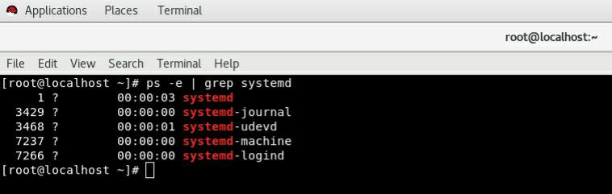

1. **Find out your terminal name.Using your terminal name, use ps to find all processes associated**

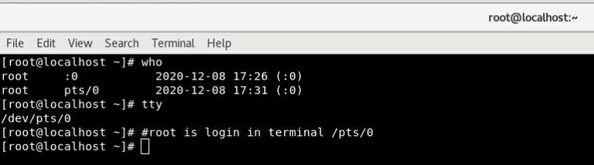**#/pts/0 is login terminal for root here**

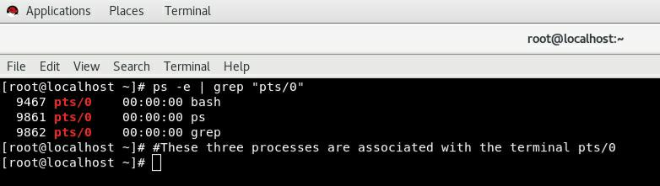

1. **Check and note the process id of your shell(from the output of the above command).**

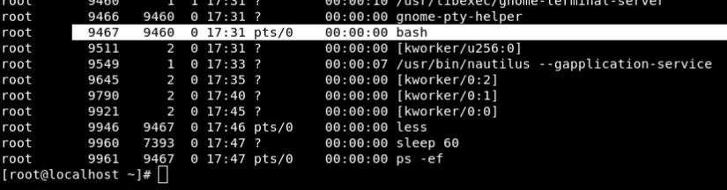**Parent PID Is 9467 and ProcessID Is 9460**

1. **Start 3 instances of “sleep 123” as background processes.**

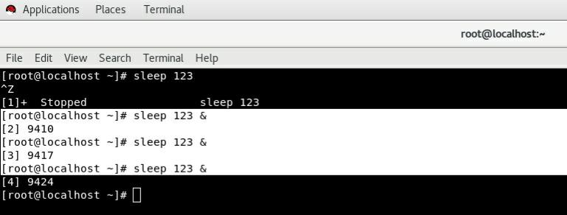

1. **Check and note the process id’s of all sleep processes.**

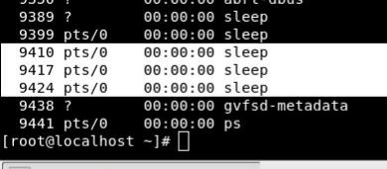

1. **Display only those three sleep processes in top. Then quit top.**

